4AO
4-channel analog isolated output module
1 product description
The 4AO type 4-channel analog isolated output module is a universal remote I/O product in the automation system, and realizes the control of 4 analog outputs through the RS485 communication interface.
This module is designed for the whole industry. The power supply, analog output and RS485 interface are electrically isolated from each other, effectively suppressing various serial and common mode interferences on the industrial site, ensuring work reliability and data accuracy. The RS485 communication interface implements the MODBUS RTU protocol and can be directly connected to various PLCs, DCS systems, man-machine screens and configuration software.
2 Features
- 4 channels of analog isolated output, 12-bit resolution, support 0~20mA/4~20mA/0~5V/1~5V/0~10V/2~10V format
- Internally integrated analog isolated power supply, no external power supply required
- Built-in hold timer to improve the security of the control system
- The configuration of current channel and voltage channel is realized by writing to the register, without the need to open the jumper setting.
- All industrial design, power supply, communication, analog output three terminals are electrically isolated from each other
- Has the function of hardware forced recovery of communication parameters factory configuration
- MODBUS RTU communication protocol
- DC10~30V wide range power input
- The maximum power consumption is only 3W
3 specification

Current output  Voltage output | 4 channels (each channel contains 1 current output and 1 voltage output), 12-bit resolution  4 channels of current output, support 0~20mA/4~20mA format  4-channel voltage output, support 0~5V/1~5V/0~10V/2~10V format  Accuracy: ±0.5%  Refresh rate: 100Hz  Built-in hold time timer, keep time constant 0~60.00s  Electrical isolation: 1500V (customizable 3000V)
Communication Interface | Physical type: RS485  Communication protocol: MODBUS RTU  Communication rate: 1200, 2400, 4800, 9600, 19200, 38400, 57600, 115200bps  Features with hardware forced recovery of communication parameters factory configuration  Electrical isolation: 1500V (customizable 3000V)
Power input | Nominal power supply: DC24V  Input range: DC10~30V  Power consumption: ≤ 4W  Protection function: anti-reverse, anti-surge
Module structure | Shape structure: Adam module, 10+10-position pluggable terminal  Installation method: DIN rail mounting
working environment | Working temperature: -25 ~ +85 °C  Ambient humidity: 10~90% RH (no condensation)
4 Terminal arrangement and description
Terminal | No. |  | Name | Schematic
1 | AO3 | I+ | Analog output 3 current channel | 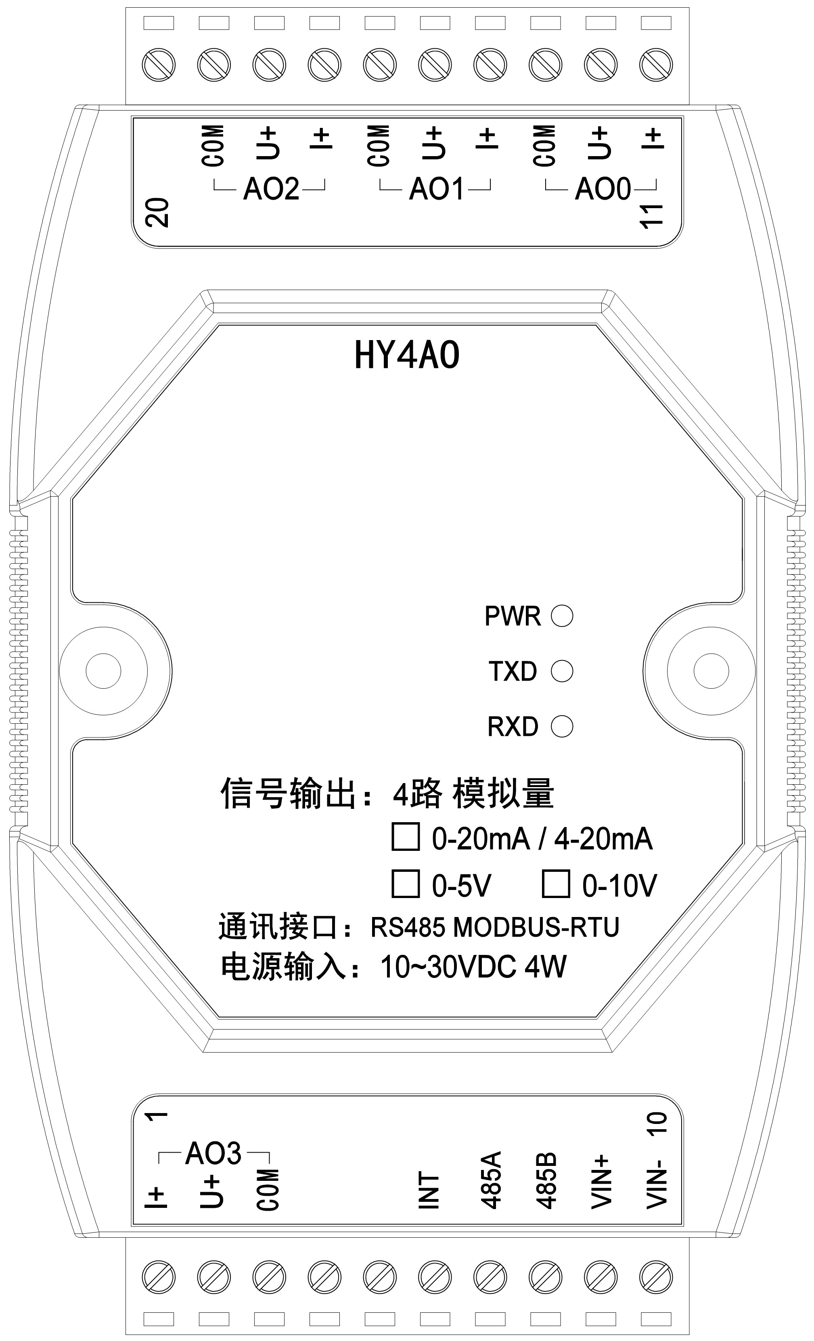
2 | AO3 | U+ | Analog output 3 voltage channel
3 | AO3 | COM | Analog output 3 common
4
5
6 | INT
7 | 485A |  | RS485 data A
8 | 485B |  | RS485 data B
9 | VIN+ |  | Power input positive
10 | VIN- |  | Power input negative
11 | AO0 | I+ | Analog output 0 current channel
12 | AO0 | U+ | Analog output 0 voltage channel
13 | AO0 | COM | Analog output 0 common
14 | AO1 | I+ | Analog output 1 current channel
15 | AO1 | U+ | Analog output 1 voltage channel
16 | AO1 | COM | Analog output 1 common
17 | AO2 | I+ | Analog output 2 current channel
18 | AO2 | U+ | Analog output 2 voltage channel
19 | AO2 | COM | Analog output 2 common

5 Indication light
Indicator mark | Name | Color | Explain
PWR | Power indication | Green | Slow flashing: power on, always on: ready, flashing: restore communication parameters
TXD | Data send | Red | Send data
RXD | Data receive | Yellow | Receive data

6 Forced recovery of communication parameters factory configuration
When the communication parameters are forgotten, or the communication parameters are changed due to misoperation, in addition to the configuration software search module, the factory configuration of the forced recovery communication parameters can also be performed. The methods and steps are as follows:
(1) Ensure that the module has been powered off;
(2) Short-circuit (connect) the INT terminal (terminal 6) and the VIN- terminal (terminal 10) with wires;
(3) The module is powered on, and the module power light flashes twice after flashing;
(4) Turn off the power and remove the short wiring;
(5) The module is powered, and the communication parameters of the module have been restored to:
Communication rate: 9600bps
Stop Bit: 1 bit
Calibration method: no parity
Local address: 1
Warning: Short circuit is invalid when the module is not powered off!

6 Supported function codes
Code | Mean | Operation
03H | Read multiple holding registers | Read one or more holding registers value
06H | Write a single holding register | Write a data to a holding register
10H | Write multiple holding registers | Write one or more data to holding register
11H | Read device properties | Read slave type and status

7 Holding register (support function codes 03H, 06H, 10H)
Address | Name | Actual value range | Bit | Range | Factory default | Read write
40001 | Communication rate | 1200/2400/4800/9600/19200/38400/57600/115200 | Bit15~12 | 0~7 | 3 | Read write
40001 | Stop bit | 0（1位）/1（2位） | Bit11~10 | 0,1 | 0 | Read write
40001 | Verification method | 0 no check / 1 even check / 2 odd check | Bit9~8 | 0,1,2 | 0 | Read write
40001 | Local address | 1~247 | Bit7~0 | 1~247 | 1 | Read write
40002 | Equipment type | 199 |  | 199 | 199 | Read only
40003 | Hardware version | H0.00~2.55 | Bit15~8 | 0~255 |  | Read only
40003 | Software version | R0.00~2.55 | Bit7~0 | 0~255 |  | Read only
40004 | Production Date | Year, the last two digits of the year, 2000 ~ 2099 | Bit15~9 | 0~99 |  | Read only
40004 | Production Date | Month， 4，1~12 | Bit8~5 | 1~12 |  | Read only
40004 | Production Date | Day，5 bit，1~31 | Bit4~0 | 1~31 |  | Read only
40005 | production code | Production number (high byte in frone) |  | 0~65535 |  | Read only
40006 | equipment status | 0 power on (self-test) / 1 ready / 2 fault |  | 0~2 |  | Read only
40007 | Hold time constant | 0~60.00s[Note 1] |  | 0~6000 | 0 | Read write
40008 | AO0 Signal format | 0（0~20mA,0~10V）  1（0~10mA,0~5V）  2（4~20mA,2~10V）[Note 2]  3（2~10mA,1~5V）[Note 2] |  | 0~3 | 0 | Read write
40009 | AO1 Signal format |  |  | 0~3 | 0 | Read write
40010 | AO2 Signal format |  |  | 0~3 | 0 | Read write
40011 | AO3 Signal format |  |  | 0~3 | 0 | Read write
40012 | AO0预置[注3] | Analog output 0 channel |  | 0~4095 | 0 | Read write
40013 | AO1 Preset | Analog output 1 channel |  | 0~4095 | 0 | Read write
40014 | AO2 Preset | Analog output 2 channel |  | 0~4095 | 0 | Read write
40015 | AO3 Preset | Analog output 3 channel |  | 0~4095 | 0 | Read write
40016 | AO0 given | Analog output 0 channel |  | 0~4095 | 0 | Read write
40017 | AO1 given | Analog output 1 channel |  | 0~4095 | 0 | Read write
40018 | AO2 given | Analog output 2 channel |  | 0~4095 | 0 | Read write
40019 | AO3 given | Analog output 3 channel |  | 0~4095 | 0 | Read write
[Note 1] When the output keeps constant at 0, it means that each given AO output will continue until a new given value is written. When it is 1 ~ 6000, it means that if the given AO output does not update the reference again when the specified holding time is reached, the AO output will return to the initial state (ie, preset value).
[Note 2] When the Signal format is set to 2 (4 ~ 20mA, 2 ~ 10V) or 3 (2 ~ 10mA, 1 ~ 5V), the given output will not be less than 819. If a value less than 819 is given, the given value will become 819 and output.
[Note 3] Preset value-when the module is powered on, or when the hold time is reached, the output static value of the channel.

8 Device attribute register (support function code 11H)
Byte | Name | Actual value range | bit | Range | Read write
2 | Equipment type | 199 |  | 199 | Read only
2 | hardware version | H0.00~2.55 | Bit15~8 | 0~255 | Read only
2 | Software version | R0.00~2.55 | Bit7~0 | 0~255 | Read only
2 | Production Date | 年，年的后两位，2000~2099 | Bit15~9 | 0~99 | Read only
2 | Production Date | 月，占4位，1~12 | Bit8~5 | 1~12 | Read only
2 | Production Date | 日，占5位，1~31 | Bit4~0 | 1~31 | Read only
2 | production code | Production number (high byte first) |  | 0~65535 | Read only
2 | equipment status | 0 power on (self-test) / 1 ready / 2 fault |  | 0~2 | Read only

